**J1 Waiver Approved For a Student from Togo with US Department of State Government Funding.**

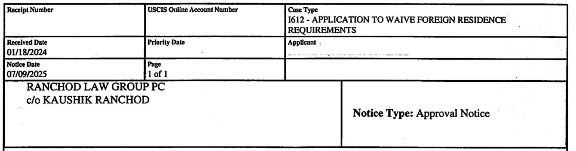

Our legal team successfully secured an exceptional hardship waiverfor a J-1 exchange visitor whose departure from the United States would have caused severe hardship to his U.S. citizen children. The case presented a compelling combination of financial, educational, and medical challenges that would have been insurmountable if the family were forced to relocate abroad.

When our client first came to the United States on a J-1 visa to pursue advanced graduate studies, the move offered new opportunities for his career and family. Over time, however, his circumstances changed significantly. The cost of living in his home country had sharply increased, while his earning potential there remained extremely limited. If the waiver had been denied, the entire family—his spouse, their U.S. citizen children, and dependent relatives—would have had no choice but to move to a country where salaries were far lower and quality healthcare was inaccessible.

The hardship was particularly severe for one of the children, who requires ongoing specialized medical treatment that is readily available in the U.S. but not in the family’s home country. Past visits abroad had already shown that the child’s condition worsened without proper care, underscoring the urgency of maintaining access to U.S.-based treatment. In addition, the cost of private education overseas would have been prohibitively expensive, making it impossible for the children to receive the same standard of schooling they currently enjoy.

To strengthen the case, our team developed a detailed legal argument supported by extensive documentation, including country condition reports, economic data, and expert medical evidence. We clearly demonstrated how relocation would disrupt not only the children’s health and education but also the family’s financial stability, creating a direct and profound impact on their well-being.

USCIS agreed, granting the exceptional hardship waiver and allowing the family to remain together in the United States. This outcome ensures the children will continue to have access to life-saving medical care, stable schooling, and the supportive environment they need to thrive.